**CHAPTER 1**

**INTRODUCTION**

**INTRODUCTION**

Tumour is an abnormal mass of tissue. Tumours can be benign or malignant (cancerous). There are hundreds of different types of tumours. Their names usually reflect the kind of tissue they arise in, and may also tell you something about their shape or how they grow. Diagnosis depends on the type and location of the tumour. Tumour marker tests and imaging may be used; some tumours can be seen (for example, tumours on the exterior of the skin) or felt (palpated with the hands).

A brain tumour occurs when abnormal cells from within the brain. There are two main types of tumours: malignant or non-cancerous tumours and benign tumours.

Cancerous tumour can be divided into primary tumours, which start within the brain and the secondary tumours, which have spread from elsewhere, known as brain metastasis tumours.

All the types of brain tumours may produce symptoms that vary depending on the part of the brain that is affected. These symptoms may include headaches, seizures, problems with vision, vomiting and mental changes. The headache is classically worse in the morning and goes away with vomiting. Other symptoms may include difficulty in walking, speaking or with sensations. As the disease progresses, unconsciousness may occur. Medical images plays a vital role in brain tumour. Early imaging methods invasive and sometimes dangerous, Pneumoencephalography and cerebral angiography have been abandoned in favour of non-invasive, high resolution techniques.

The brain is an important organ that controls thought, memory, emotion, touch, motor skills, vision, respiration, body temperature, hunger, and many other processes that regulate our body. The spinal cord is a large bundle of nerve fibers that extends from the base of the brain to the lower back. It carries messages to and from the brain and the rest of the body.

A brain tumour is a growth of abnormal cells inside the brain. Most brain tumours that children get are called primary brain tumours, meaning that they originated in the brain and did not spread from somewhere else. Tumours might be localized, remaining in one area, or they might be invasive, spreading into nearby tissues. Tumours are also categorized as benign (non-cancerous) or malignant (cancerous). However, it is difficult to call any brain tumour "benign", because all can cause serious problems.

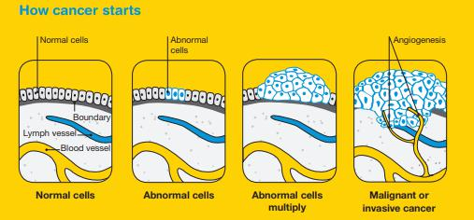

Fig 1.1 Tumour development stages

**1.1 BRAIN CANCER STATISTICS:**

A primary brain or spinal cord tumour is a tumour that starts in the brain or spinal cord. This year, an estimated 23,880 adults (13,720 men and 10,160 women) in the United States was diagnosed with primary cancerous tumours of the brain and spinal cord. Brain tumours account for 85% to 90% of all primary CNS tumours. Also, about 3,560 children will be diagnosed with a brain or CNS tumour this year.

Brain and other nervous system cancer are the 10th leading cause of death for women. It is estimated that 16,830 adults (9,490 men and 7,340 women) will die from primary cancerous brain and CNS tumours this year.

The 5-year survival rate tells you what percent of people lived at least 5 years after the tumour is found. Percent means how many out of 100. The 5-year survival rate for people with cancerous brain or CNS tumours is 34% for men and 36% for women. However, survival rates vary widely and depend on several factors, including the type of brain or spinal cord tumour. Talk with your doctor about what to expect with your diagnosis.

Brain cancer was the 18th most commonly diagnosed cancer in Australia in 2014. It is estimated that it will become the 17th most commonly diagnosed cancer in 2018.

In 2016, there were 1,439 deaths from brain cancer in Australia (878 males and 561 females). In 2018, it is estimated that there will be 1,435 deaths (856 males and 579 females). In 2018, it is estimated that the risk of an individual dying from brain cancer by their 85th birthday will be 1 in 157 (1 in 128 males and 1 in 200 females).

The number of new cases of brain cancer diagnosed increased from 853 (491 males and 362 females) in 1982 to 1,710 in 2014. Over the same period, the age–standardised incidence rate increased from 6.3 cases per 100,000 persons (7.5 for males and 5.1 for females) in 1982 to 6.7 cases per 100,000 in 2014.

The number of deaths from brain cancer increased from 391 (246 males and 145 females) in 1968 to 1,439 in 2016. Over the same period, the age–standardised mortality rate increased from 3.6 deaths per 100,000 persons (4.6 for males and 2.7 for females) in 1968 to 5.3 deaths per 100,000 in 2016.

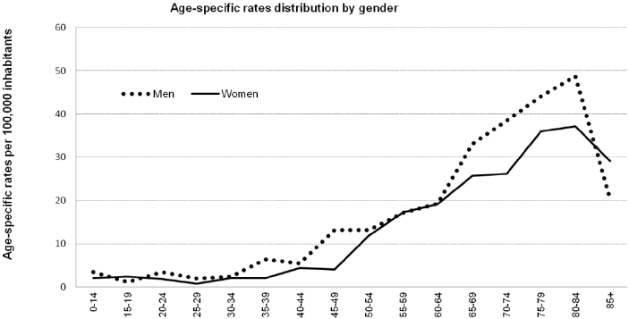

**Figure 1.2 Brain Cancer Statistics**

**Source:** American Society of Clinical Oncology (ASCO).

Link: https://www.cancer.net/cancer-types/brain-tumour/statistics

National Brain Tumour Society

Link: http://blog.braintumour.org/brain-tumour-facts-figures-may-2018-incidence-mortality-and-survival-in-2018/

**1.2 TYPES OF BRAIN TUMOUR**

**Benign tumour:** This kind of tumour is not cancer. It tends to grow slowly.Most benign brain tumours don’t grow into nearby tissue. Once removed, they usually don’t grow back. A benign tumour can cause symptoms like a malignant tumour depending on its size and location in the brain.

**Malignant tumour:** This kind of tumour is cancer. It usually grows fast, and growsinto nearby tissue. This can make it hard to remove fully. A malignant brain tumour may grow back after treatment.

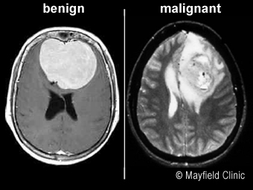

**Figure 1.3 Brain Tumour Images**

Brain tumours can be classified into two general groups:

* Primary brain tumour
* Secondary brain tumour

**1.2.1 PRIMARY BRAIN TUMOUR**

Primary brain tumours are named by the type of brain tissue where they’re found. The most common type of primary brain tumour is a glioma. This type begins in the supportive (glial) tissue of the brain. Some gliomas tend to grow slowly. Others grow and spread quickly.

Some types of glioma include:

**Astrocytoma:** This kind of tumour comes from small star-shaped cells calledastrocytes. In adults, an astrocytoma usually grows in the cerebrum. In children, they can grow in the cerebellum, cerebrum, and brain stem. Most astrocytoma’s spread into nearby normal brain tissue and are hard to cure with surgery. Glioblastoma is a type of astrocytoma that tends to grow very quickly.

5

**Brain stem glioma:** This kind of tumour of the brain stem is more common in

children than in adults. Because the brain stem controls many important functions, such as breathing and heart rate, this kind of tumour usually can’t be removed by surgery.

**Ependymoma:** This kind of tumour starts in cells that line the fluid-filled spaceswithin the brain (ventricles). It doesn’t often grow into nearby brain tissue. This means in some cases it can be cured with surgery.

**Oligodendroglioma:** This kind of tumour starts in cells that make myelin, the fattysubstance that surrounds nerve cells. Like an astrocytoma, this tumour tends to spread into nearby brain tissue and is often hard to cure with surgery.

**Optic nerve glioma:** This kind of tumour grows in or around the nerve that sendsmessages from the eyes to the brain. This can cause vision changes. It can also cause hormone changes, due to its location near the pituitary gland. Other types of primary tumours include:

**Primitive Neuroectodermal Tumour (PNET):** This kind of tumour grows moreoften in children. It can grow anywhere in the brain in the primitive form of nerve cells. One type is the medulloblastoma. This kind of tumour is found in the cerebellum. They are more common in children than in adults. They tend to grow and spread quickly, but they can often be treated effectively.

**Tumour of the pineal gland:** This kind of tumour grows in and around the pinealgland. This is a tiny organ near the centre of the brain. The tumour can be slow-growing, called pineocytoma. Or it can be fast-growing, called pineoblastoma.

**Pituitary tumour:** This kind of tumour starts in the pituitary gland at the base of thebrain. It is almost always benign. But it can cause serious symptoms because of its location, and because it may secrete excess hormones.

**Craniopharyngioma:** This kind of tumour starts near the pituitary gland. It isusually slow growing. But it can cause symptoms if it presses on the pituitary gland or on nearby nerves.

**Schwannoma:** This kind of tumour starts in myelin-making cells that surroundcertain nerves. It’s most common in the vestibular nerve in the inner ear that helps with balance. If it grows there, the tumour is called a vestibular schwannoma or an acoustic neuroma. This type of tumour is usually benign.

**Meningioma:** This kind of tumour starts in the outer linings of the brain (meninges).It is more common in adults. Many meningiomas can be removed with surgery, but some may grow back.

**Primary central nervous system lymphoma:** This is an aggressive, rare type oftumour that starts in lymphocytes. This is a type of immune cell. The tumour is more common in people with a disease of the immune system, such as AIDS. But it can grow in healthy people.

**1.2.2 SECONDARY BRAIN TUMOUR**

A secondary brain tumour is also known as a metastatic brain tumour. This is cancer that starts in another organ and then travels to the brain. In adults, secondary brain tumours are more common than primary brain tumours. Cancer in the brain that has spread from another part of the body is not considered brain cancer. It is still the same type of cancer as where it started. For example, lung cancer that has spread to the brain is called metastatic lung cancer.

These are some of the most common types of cancer that spread to the brain:

* Lung cancer
* Breast cancer
* Melanoma
* Colon cancer
* Kidney cancer

**1.3 ORGANISATION OF THE PROJECT REPORT**

**Chapter 2:** Deals with the previously proposed method and their disadvantages in the methods, and the need to choose a new method.

**Chapter 3:** Details about the microstrip patch antenna for biomedical applications. The simulation results about the patch antenna using Computer Simulation Technology (CST) Software have been discussed. Then about Hardware description also discussed.

**Chapter 4:** Deals with Experiments results and conclusion, we have done both the hardware and software experiments and the results have been successfully verified.

**Chapter 5:** Conclusion of our project have been explained here and future improvement of the project is also well explained.

**CONCLUSION**

Hence the proposed method for detecting brain tumour using Specific Absorption Rate of the microstrip antenna. Here the human brain cells Specific Absorption Rate will be taken as input so that we can identify the tumour cells. This work has introduced one brain tumour detection method to increase the accuracy and yield and decrease the diagnosis time and mainly decrease the side effects caused due to the radiation. The goal is to detect tumour cells from the Brain. The Specific Absorption Rate of human cells and tumour cells are different, this easily helps the identification of tumour. The frequency sent from the patch antenna is absorbed at a high rate by the tumour cells than healthy human cells. By this we can find the presence of tumour cells.